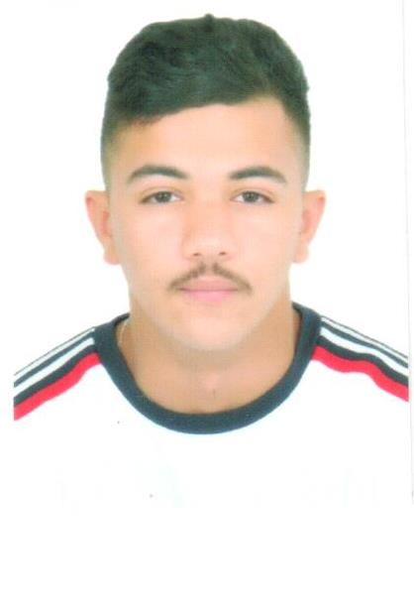PERSONAL INFORMATION

Name: Rashed Jasem Rashed Alamar.

Marital Status: Single.

Dateof Birth: 20/04/2002

Place of Birth: Manama Bahrain.

Nationality: Bahraini

CPR: 020405820

Address: Busaiteen

Tel: +973-33776521

EDUCATIONAL QUALIFICATIONS

* High School 2018-2019.

EXPERIENCES

* 6months experiences customer service at carriage

PERSONAL SKILLS

* Speaking and Writing English
* Master the Arabic language.

Languages

* English
* Arabic

OTHER SKILLS

* I have the spirit of leadership and advice.
* Love to work with teams
* Hardworker
* Have the will to join immediately

INTERESTS AND HOBBIES

* Photography.
* Writing.
* Reading.

DECLARATION:

All the information gives above are the true to the best of my knowledge and believe.